Winter Break Home work
Session 2019-2020
Class: XI A
Subject: Computer Science with Python

Q 1 a) What do you mean by DDL and DML commands?Give an example of each | (2)

b)Consider the following table Organisation and Grossincome and answer (I) and (II) part of the question:
 |  |  |  |  |  | Table: ORGANISATION
 | ECODE |  | NAME |  |  | POST |  |  | SGRAD |  | DOJ |  | DOB
 |  |  |  |  |  |  |  |  | E
 | 2001 |  | AJAY |  |  | GENERAL MANAGER |  |  | D003 |  | 23-Mar-2003 |  | 13-Jan-1980
 | 2002 |  | VIJAY |  |  | EXECUTIVE MANAGER |  |  | D002 |  | 12-Feb-2010 |  | 22-Jul-1987
 | 2003 |  | RAM |  |  | DEPUTY MANAGER |  |  | D003 |  | 24-Jan-2009 |  | 24-Feb-1983
 | 2004 |  | RAHIM |  |  | PROD. INCHARGE |  |  | D002 |  | 11-Aug-2006 |  | 03-Mar-1984
 | 2005 |  | ABBA |  |  | ADD.GENERAL |  |  | D001 |  | 29-Dec-2004 |  | 19-Jan-1982
 |  |  | S |  |  | MANAGER
 |  |  |  |  |  | Table:GROSSINCOME
 | SGRADE |  |  |  |  | SALARY |  |  |  |  | HRA
 | D001 |  |  |  |  | 56000 |  |  |  | 18000
 | D002 |  |  |  |  | 32000 |  |  |  | 12000
 | D003 |  |  |  |  | 24000 |  |  |  | 8000
 | (I) Write SQL commands for the following statements: |  |  |  |  |  |  |  |  |  |  | (4)

a) To display the details of all MEMBERS OF ORGANISATION in descending order of DOJ.
b) To display NAME and POST of those MEMBERS whose SGRADE is either D002 or D003.

c) To display the content of all the ORGANISATION table, whose DOJ is in between 09-Feb-2006 and 08-Aug-2009.

d) To add a new row with the following

2007, ‘RUDRA’, ‘SALES INCHARGE’, ‘D002’,’26-Sep-2011’, ’26-Sept-1983’
(II) Give the output of the following SQL queries : | (2)
a) SELECT COUNT(SGRADE), SGRADE FROM ORGANISATION GROUP BY SGRADE;
- SELECT MIN(DOB), MAX(DOJ) FROM ORGANISATION;
- SELECT NAME,SALARY FROM ORGANISATION O, GROSSINCOME G
WHERE O.SGRADE=G.SGRADE AND O.ECODE<2003;

- SELECT SGRADE, SALARY+HRA FROM GROSSINCOME WHERE SGRADE=’D002’

Q2.Write SQL Command for (a) to (d) and output of (g)

TABLE : GRADUATE

S.NO | NAME | STIPEND | SUBJECT | AVERAGE |  | DIV
1 | KARAN | 400 | PHYSICS | 68 |  | I
2 | DIWAKAR | 450 | COMP. Sc. | 68 |  | I
3 | DIVYA | 300 | CHEMISTRY | 62 |  | I
4 | REKHA | 350 | PHYSICS | 63 |  | I
5 | ARJUN | 500 | MATHS | 70 |  | I
6 | SABINA | 400 | CEHMISTRY | 55 |  | II
7 | JOHN | 250 | PHYSICS | 64 |  | I
8 | ROBERT | 450 | MATHS | 68 |  | I
9 | RUBINA | 500 | COMP. Sc. | 62 |  | I
10 | VIKAS | 400 | MATHS | 57 |  | II

a) List the names of those students who have obtained DIV I sorted by NAME.

b) Display a report, listing NAME, STIPEND, SUBJECT and amount of stipend received in a year assuming that the STIPEND is paid every month.

c) To count the number of students who are either PHYSICS or COMPUTER SC graduates.
d) To insert a new row in the GRADUATE table: 11,”KAJOL”, 300, “computer sc”, 75, 1

g) Give the output of following sql statement based on table GRADUATE:
  - i) Select MIN(AVERAGE) from GRADUATE where SUBJECT=”PHYSICS”;

  - ii) Select SUM(STIPEND) from GRADUATE WHERE div=2;
  - iii) Select AVG(STIPEND) from GRADUATE where AVERAGE>=65;
  - iv) Select COUNT(distinct SUBJECT) from GRADUATE;
3(a) | At the time of creation of table X, the data base administrator specified Y as the  Primary key. Later on he realized that instead of Y, the combination of column P and  Q should have been the primary key of the table. Based on this scenario, answer the following questions:  a. Is it possible to keep Y as well as the combination of P and Q as the primary key?  b. What statement(s) should be entered to change the primary key as per the  requirement.
(b) | What is the difference between Drop and Delete Command?
( c) | Consider the following table : Supplier. Write SQL queries for (i) to (vi)  Table : SUPPLIER  SuppNo SuppName Status City QtySupp ItemNo  S10 Britannia C Chennai 100 12  S20 Mother Dairy C Mumbai 200 13  S30 Nirula’s L Delhi 200 16  S40 Haldiram L Bangalore 400 14  S50 Bikaner L Jaipur 300 14  - Find the total quantity supplied by all the suppliers  - Display a report listing supplies number, status and item number for all those  suppliers who have supplied quantities greater than or equal to 200.  - Count the number of supplier who has supplied quantity greater than or equal to 200.  - Display a list of all suppliers supplying item number 14 and sorted by quantity supplied.  - Display the quantity supplied for each status.  - Increase quantity supplied by 10 for city Delhi.
4(a) | There is a table T1 with combination of columns C11, C12, and C13 as its primary key? Is it possible to enter:  a. NULL values in any of these columns?  b. Duplicate values in any of these columns?
(b) | In a database there is a table Company . The data entry operator is not able to put  duplicate values in a column of Company ? What may be the possible reason(s)?  In a database there is a table Company . The data entry operator is not able to put  NULL in a column of Company? What may be the possible reason(s)?
(c ) | Consider the following tables FURNITURE and TYPE. Write SQL commands for the statements (i) to (iv) and give outputs for SQL queries (v) to (viii) 6  TABLE : FURNITURE  FID FNAME TYPENO CHARGES ARRIVAL  1 WHITE LOTUS F01 30000 21-11-2012  2 PINK FEATHER F02 7500 16-11-2012  3 DOLPHIN F02 9500 14-11-2012  4 DECENT F01 25000 5-09-2011  5 COMFORT F03 15000 12-10-2011  6 ROYAL F02 6500 3-05-2011  7 ECONO F03 9500 1-06-2012  TABLE : TYPE  TYPENO TYPENAME DISCOUNT  F01 DOUBLE BED 30  F02 BABY COT 20  F03 OFFICE TABLE 10  - To display all the details of furniture whose CHARGES is more than 10000  - To increase the CHARGES of furniture by 5% of existing charge for furniture arrived after 1-09-2011  - To display the details of furniture of type OFFICE TABLE  - To insert a new row with the following data in FURNITURE table  8, “Velvet Touch”, “F01” , 25000, “25-03-2011”  - Select TYPENO, count(* ) from FURNITURE group by TYPENO;  - Select FNAME, CHARGES from FURNITURE where FNAME like “ %T “;

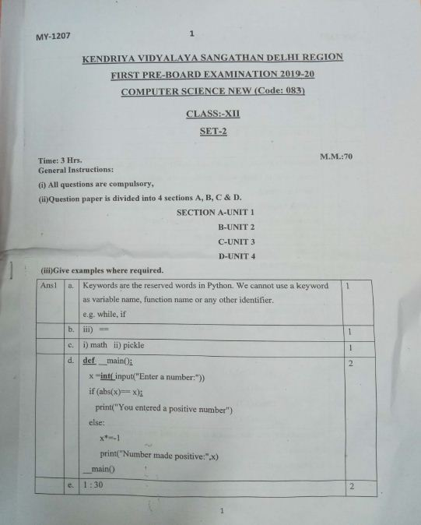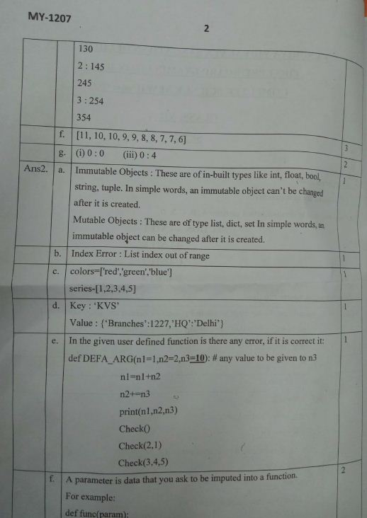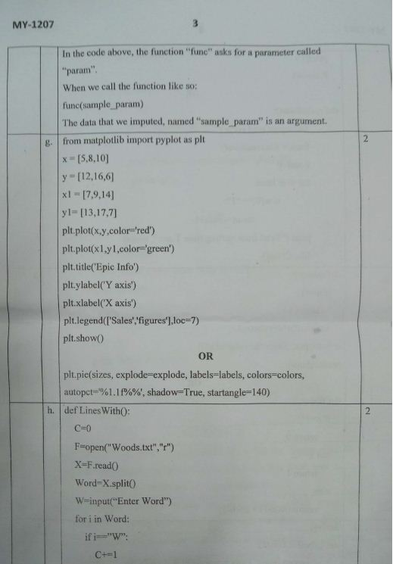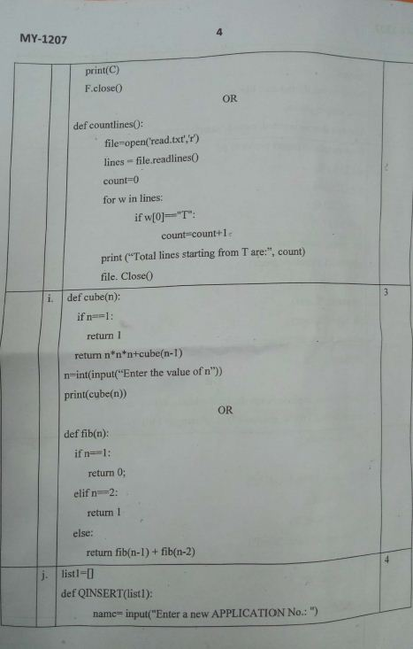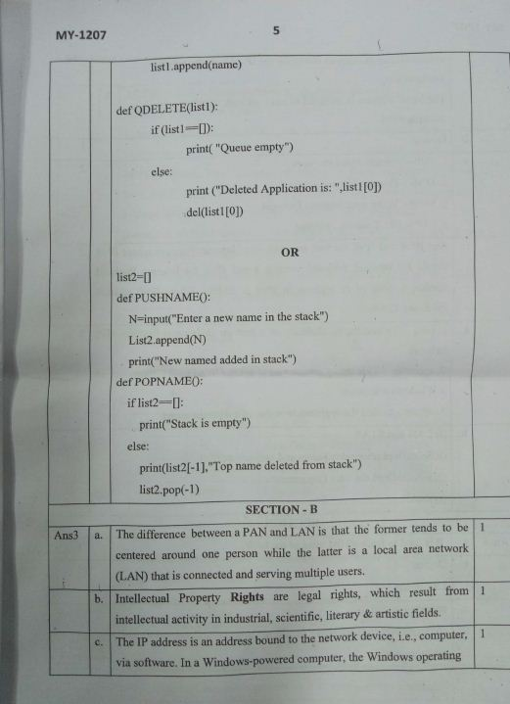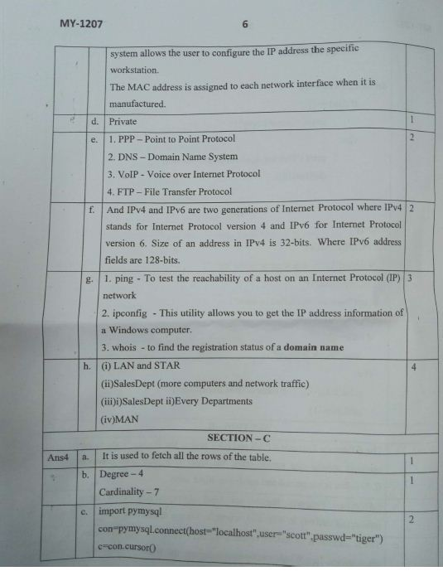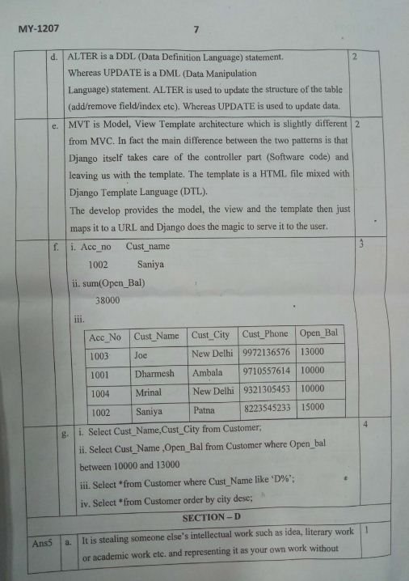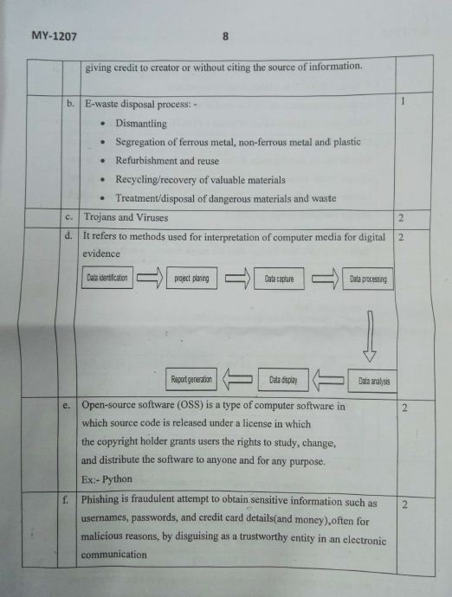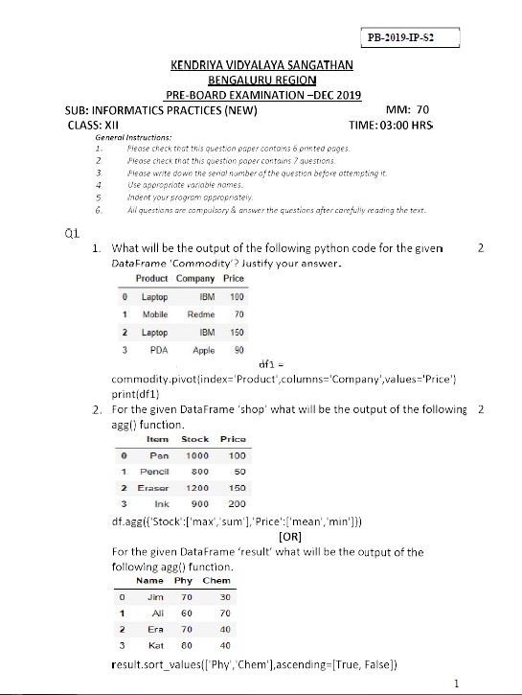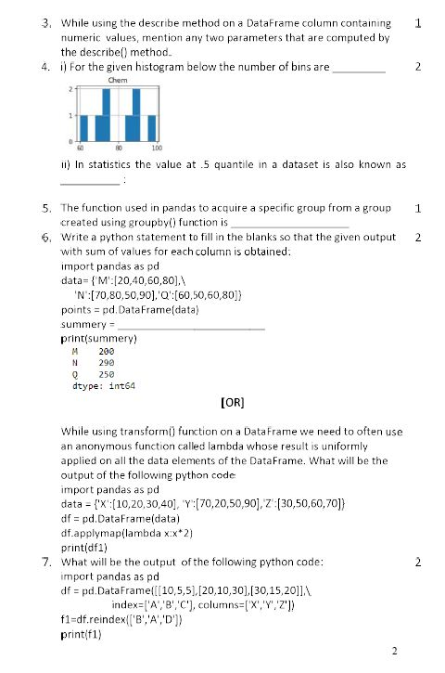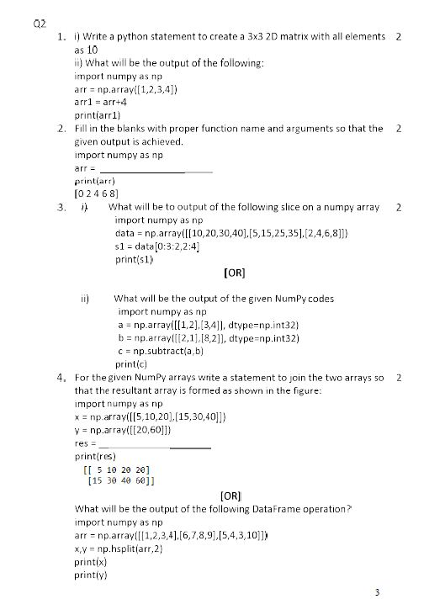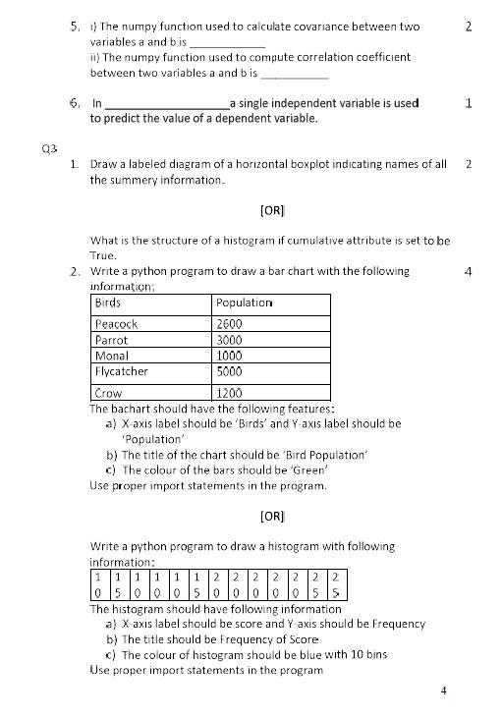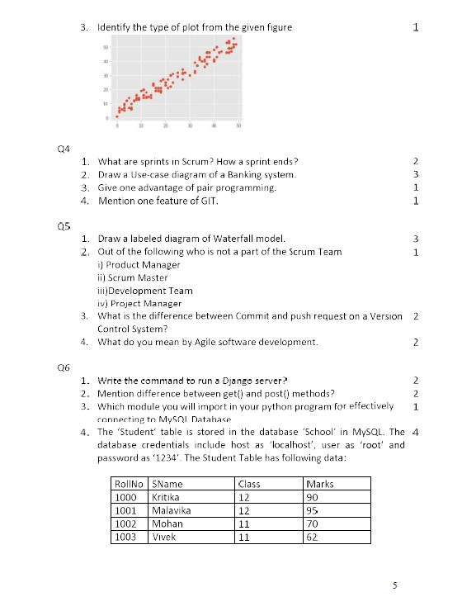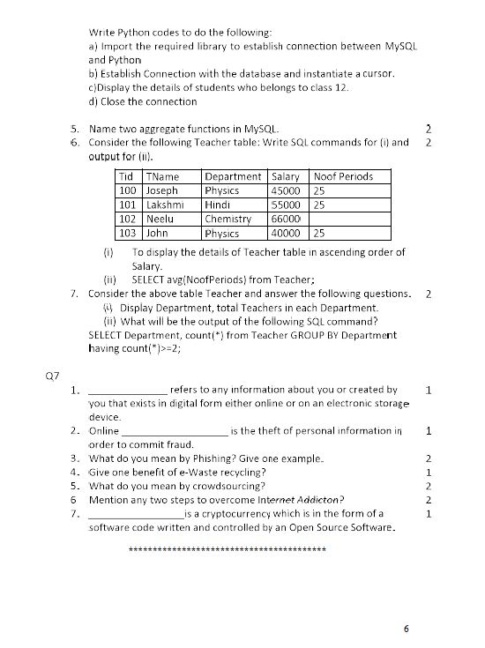
Winter Break Home work
Session 2019-2020
Class: XI B
Subject: Information Practices

1(a) | Write an SQL query to create the table “BookDetails“ with the following structure-  Field Type Constraint  Book_Id Varchar(4) Primary Key  Book_Name Varchar(30)  Author_Name char(30) Default “BPB”  Publisher Varchar(20)  Price Integer Check Price >0  Type Varchar(15)  Quantity Integer Not Null | 2
(b) | In a database there are two tables ‘Patient’ and ‘Doctors’ are shown below-  Table: Patient  Name Patient_No Date_Adm Doctor_No  Aneesh P104 2009-05-15 502  Shraddha K P202 2010-01-11 165  Reshmi Nair P754 2007-12-31 325  Sunitha P P612 2010-04-22 165  Table: Doctor  Doctor_No Doctor_Name Specialty  122 Dr. Sabir Khan Urology  165 Dr.R. K. Tiwari Neurology  325 Dr. S.L. Sargaiya Surgery  502 Dr. Priya Nephrology  530 Dr. Kamal Kishore Dentist  i) Name the columns which can be made ‘Primary Key’ in both the tables.  ii) What will be the cardinality of Cartesian product of both the tables? | 2
c | Consider the tables given below.  Table : STOCK  Itcode Itname Dcode Qty unitpr Stkdate  452 Drawing Sheet 101 80 21 31-June-2017  457 Sharpener Camlin 102 65 13 21-Apr-2017  467 Eraser Natraj 101 40 6 11-Dec-2017  469 Gel Pen Montex 103 56 10 03-Jan-2017  407 Geometry Box 101 30 65 15-Nov-2017  421 Parker Premium 102 60 109 27-Oct-2017  427 Office File 103 20 34 13-Sep-2017  Table : DEALERS  Dcode Dname Location  101 Vikash Stationers Lanka Kanpur  102 Bharat Drawing Emporium Luxa Lucknow  103 Banaras Books Corporation Bansphatak Varanasi  With reference to these tables, write commands in SQL for (i) and (ii) and output for (iii) below-  - To display the amount that has been spent to purchase Office file & Sharpener camlin.  - To display all the items of Vikash Stationers.  (iii) SELECT DCODE,COUNT(QTY),AVG(UNITPR) FROM STOCK GROUP BY DCODE; | 6
2(a) | What is Primary Key and Candidate Key? Discuss with example. | 2
(b) | What is the difference between Drop and Delete Command? Discuss with example. | 2
( c) | Consider the following table : Supplier. Write SQL queries for (i) to (vi) | 6
Table : SUPPLIER
SuppNo | SuppName | Status | City | QtySupp | ItemNo
S10 | Britannia | C | Delhi | 10 | 12
S20 | Mother Dairy | C | Bangalore | 20 | 13
S30 | Nirula’s | L | Goa | 20 | 16
S40 | Haldiram | L | Trivandrum | 40 | 14
S50 | Bikaner | L | Chennai | 30 | 14

- Find the total quantity supplied by all the suppliers
- Display a report listing supplies number, status and item number for all those
suppliers who have supplied quantities greater than or equal to 20.
- Count the number of supplier who has supplied quantity greater than or equal to 20.
- Display a list of all suppliers supplying item number 14 and sorted by quantity supplied.
- Display the quantity supplied for each status.
- Increase quantity supplied by 10 for city Delhi.

3(a) | Write SQL to Create the following table BANK with specified constraints  Column Name Data type Constraint  BankCode Character of 10 size Primary Key  Branch Character of 30 size  Location Character of 30 size City can have only four values “Hyderabad”, ”Delhi”,”Goa”,”Bhopal”  Budget Numeric(7,2) | 2
(b) | Can we change the column name using Alter table command? Change the data type of Budget column of above mentioned BANK Table to Numeric(10,2) and add default value to 1000000. | 2
( c) | Consider the tables HANDSET AND CUSTOMER  HandSet  SetCode SetName TouchScreen PhoneCost  N1 Talk 3G N 4500  N2 Talk 4G Y 9000  B1 SamWaad N 14000  Customer  CustNo SetNo CustAddress  1 N2 Delhi  2 B1 Mumbai  3 N2 Mumbai  4 N1 Kolkata  5 B1 Delhi  - Display the Customer No, Customer address and corresponding Setname. 2  - Display the customer details for each customer who uses a Talk handset. 2  - Add a new column in Customer table with Custaccno , unique and int(6).
4(a) | Consider the following EMP and DEPT table  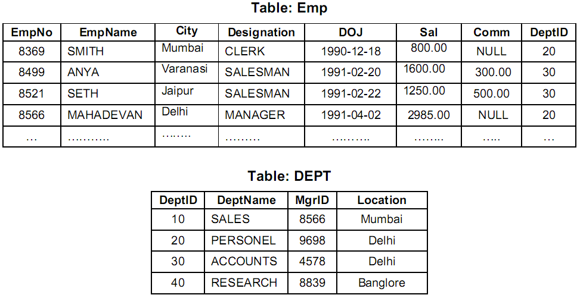  Write the SQL command to get the following. (any 6)  a. Show the minimum, maximum and average salary of Managers.  b. Count the number of Clerk in the Organization.  c. Display the Designation wise list of employees with name, Sal and Date of Joining.  d. Count the number of employees who are not getting commission.  e. Show the average salary for all departments with more than 5 working people.  f. List the count of Employees grouped by DeptID.  g. Display the maximum salary of employees in each Department.  h. Display the name of Employees along with their Designation and Department Name.  i. Count the number of Employees working in ACCOUNTS department. | 6
(b) | Write Mysql command to create the Table Employee with the given constraints.  Table: EMPLOYEE  Column Name EmpID EmpName EmpAdd EmpPhone EmpSal DeptID  Key type Primary Foreign  Null/Unique Not null unique  Foreign Key table name Department  Foreign key colomn DeptId  Data type integer char varchar integer double integer  Length 4 25 30 10 9,2 2 | 2
(c ) | Does MySQL allow to change the primary key in all cases? If there is some special  case, please mention.

KENDRIYA VIDYALAYA N0. 3 AFS CHAKERI KANPUR
WINTER BREAK HOME WORK – 2019-2020
CLASS : XII A ( Science) CHEMISTRY

- Board sample Paper from CBSE- learn the pattern of Examination
- Solve both Pre board –I paper and learn the answers
- Complete project for Board Examination-2020
- Increase writing practice.

CLASS :XI A( CHEMISTRY)

- Learn exercise questions –Answers of the following chapters
- Redox reaction (09) Hydrogen (10) The s-Block elements
(11) The p-Block elements (14) Environmental Chemistry
- Learn the question and answers properly for Periodic test-II
- Increase writing practice to develop self-confidence.
- Prepare a project for annual Examination of your choice-e.g.: Control of air pollution, Water pollution, Smog, Importance of s-and p-Block elements etc.

CLASS VII B(SCIENCE)

- Do the Exercise question of Electric current and its effects.
- Learn the exercise questions-Answers of the following topics
- Transportation in Animals and Plants
- Reproduction in Plants
- Motion and Time
- Electric current and its effect
- Study Light
- Prepare a project for annual examination on pollution, importance of water in life, save forest etc.

Subject – Maths
Class – VIIIA/B
- Algebraic Expressions
- Visualizing Solid Shapes
- Mensuration
- Exponent and Powers
(Solve all examples, try these, do these and 5 other questions from all above chapters.)

- Direct and Inverse Proportion
- Factorization
(Solve all examples, try these and do these from above two chapters.)

Class – XIA/B (Maths)
- Sequence and Series
- Straight Lines
- Conic Sections
(Solve all examples and Miscellaneous exercise from all above chapters.)

- Introduction to Three-dimensional Geometry
- Limits and Derivatives
- Mathematical Reasoning
(Solve all examples from above three chapters.)

- Complete the Maths Lab Practical / Activity File.

Class – XII (Maths)
- Do chapter wise revision of whole syllabus.
- Solve 8 latest Sample papers / Question papers of CBSE.
- Complete the Maths Lab Practical / Activity File.

M K Sharma
PGT(Maths)

HOLIDAY HOMEWORK FOR WINTER BREAK
ACCOUNTANCY-XI
1. On Jan 01, 2017 Shieba sold goods to Vishal for Rs. 10,000 and drew upon him a bill of exchange for 2 months. Vishal accepted the bill and returned it to Shieba. On the date of maturity the bill was dishonoured by Vishal. Record the necessary entries in all the cases listed below in the books of Shieba and Vishal:

(i) When the bill kept by Shieba till its maturity;
(ii) When the bill is discounted by Shieba for Rs. 200;
(iii) When the bill is endorsed to Lal Chand by Shieba.

2. Darshan sold goods for Rs. 40,000 to Varun on 8.1.2016 and drew upon him a bill of exchange payable after two months. Varun accepted the bill and returned the same to Darshan. On the due date the bill was met by Varun. Record the necessary Journal entries in the books of Darshan and Varun in the following circumstances.
When the bill was retained by Darshan till the date of its maturity.
When Darshan immediately discounted the bill @ 6% p.a. with his bank.
When the bill was endorsed immediately by Darshan in favour of his creditor Suresh.
When three days before its maturity, the bill was sent by Darshan to his bank for collection.

3. Trial balance of Rahul did not agree. Rahul put the difference to suspense account. Subsequently, he located the following errors :
(i) Wages paid for installation of Machinery Rs. 600 was posted to wages account.
(ii) Repairs to Machinery Rs. 400 debited to Machinery account.
(iii) Repairs paid for the overhauling of second hand machinery purchased Rs. 1,000 was debited to Repairs account.
(iv) Own business material Rs. 8,000 and wages Rs. 2,000 were used for construction of building. No adjustment was made in the books.
(v) Furniture purchased for Rs. 5,000 was posted to purchase account as Rs. 500.
(vi) Old machinery sold to Karim at its book value of Rs. 2,000 was recorded through sales book.
(vii) Total of sales returns book Rs. 3,000 was not posted to the ledger.
Rectify the above errors and prepare suspense account to ascertain the original difference in trial balance.
4. Rectify the following errors assuming that suspense account was opened. Ascertain the difference in trial balance.
(a) Credit sales to Mohan Rs. 7,000 were recorded in Purchase Book. However, Mohan’s account was correctly debited.
(b) Credit purchases from Rohan Rs. 9,000 were recorded in sales book. However, Rohan’s account was correctly credited.
(c) Goods returned to Rakesh Rs. 4,000 were recorded in sales return book. However, Rakesh’s account was correctly debited.
(d) Goods returned from Mahesh Rs. 1,000 were recorded through purchases return book. However, Mahesh’s account was correctly
credited.
(e) Goods returned to Naresh Rs. 2,000 were recorded through purchases book. However, Naresh’s account was correctly debited.

5. Prepare a trading account of M/s Anjali from the following information related to March 31, 2017.
Rs.
Opening stock 60,000
Purchases 3, 00,000
Sales 7, 50,000
Purchases return 18,000
Sales return 30,000
Carriage on purchases 12,000
Carriage on sales 15,000
Factory rent 18,000
Office rent 18,000
Dock and Clearing charges 48,000
Freight and Octroi 6,500
Coal, Gas and Water 10,000

6. Following balance is extracted from the books of a trader ascertain gross profit, operating profit and net profit for the year ended March 31, 2017.
Particulars Amount
Rs.
Sales 75,250
Purchases 32,250
Opening stock 7,600
Sales return 1,250
Purchases return 250
Rent 300
Stationery and printing 250
Salaries 3,000
Misc. expenses 200
Travelling expenses 500
Advertisement 1,800
Commission paid 150
Office expenses 1,600
Wages 2,600
Profit on sale of investment 500
Depreciation 800
Dividend on investment 2,500
Loss on sale of old furniture 300
Closing stock (March 31, 2017) valued at Rs. 8,000

7. Mrs. Vandana runs a small printing firm. She was maintaining only some records, which she thought, were sufficient to run the business. On April 01, 2016, available information from her records indicated that she had the following assets and liabilities: Printing Press Rs. 5,00,000, Buildings Rs. 2,00,000, Stock Rs. 50,000, Cash at bank Rs. 65,600, Cash in hand Rs. 7,980, Dues from customers Rs. 20,350, Dues to creditors Rs. 75,340 and Outstanding wages Rs. 5,000. She withdrew Rs. 8,000 every month for meeting her personal expenses. She had also introduced Rs. 15,000 during the year as additional capital. On March 31, 2017 her position was as follows : Press Rs. 5, 25,000, Buildings Rs. 2,00,000, Stock Rs. 55,000, Cash at bank Rs. 40,380, Cash in hand Rs. 15,340, Dues from customers Rs. 17,210, Dues to creditors Rs. 65,680.
Calculate the profit made by Mrs. Vandana during the year using statement of affairs method.

8. From the following information, Calculate Capital at the beginning :
Rs.
Capital at the end of the year 4,00,000
Drawings made during the year 60,000
Fresh Capital introduce during the year 1,00,000
Profit of the current year 80,000

9. From the information given below ascertain the profit for the year :
Rs.
Capital at the beginning of the year 70,000
Additional capital introduced during the year 17,500
Stock 59,500
Sundry debtors 25,900
Business premises 8,600
Machinery 2,100
Sundry creditors 33,400
Drawings made during the year 26,400

BUSINESS STUDIES

1. What are the different parameters used to measure the size of business?
2. What is the definition used by Government of India for Small Scale Industries?
3. What are the incentives provided by the Government for industries in backward and hilly areas?
4. Multiple Choice Questions
Tick (ü) the correct answer out of the given alternatives
1. Equity shareholders are called
(a) Owners of the company (b) Partners of the company
(c) Executives of the company (d) Guardian of the company
2. The term ‘redeemable’ is used for
(a) Preference shares (b) Commercial paper
(c) Equity shares (d) Public deposits
3. Funds required for purchasing current assets is an example of
(a) Fixed capital requirement (b) Ploughing back of profits
(c) Working capital requirement (d) Lease financing
4. ADRs are issued in
(a) Canada (b) China
(c) India (d) USA
5. Public deposits are the deposits that are raised directly from
(a) The public (b) The directors
(c) The auditors (d) The owners
6. Under the lease agreement, the lessee gets the right to
(a) Share profits earned (b) Participate in the by the lessor management of the organisation
(c) Use the asset for a (d) Sell the assets specified period
7. Debentures represent
(a) Fixed capital of the company (b) Permanent capital of the company
(c) Fluctuating capital of (d) Loan capital of the the company company
8. Under the factoring arrangement, the factor
(a) Produces and distributes (b) Makes the payment on the goods or services behalf of the client
(c) Collects the client’s debt (d) Transfer the goods from or account receivables one place to another
9. The maturity period of a commercial paper usually ranges from
(a) 20 to 40 days (b) 60 to 90 days
(c) 120 to 365 days (d) 90 to 364 days
10. Internal sources of capital are those that are
(a) generated through outsiders (b) generated through loans such as suppliers from commercial banks
(c) generated through issue (d) generated within of shares the business

5. Short Answer Questions
1. What is meant by internal trade?
2. Specify the characteristics of fixed shop retailers.
3. What purpose is served by wholesalers providing warehousing facilities?
4. How does market information provided by the wholesalers benefit the manufacturers?
5. How does the wholesaler help the manufacturer in availing the economies of scale?
6. Distinguish between single line stores and speciality stores. Can you identify such stores in your locality?

शीतकालीन गृहकार्य 2019-20
कक्षा सातवीं ‘अ’, ‘ब’
पूरक पुस्तिका के पाठों (राजदूत संजय से भीष्म शर शैया पर) के लघु प्रश्नोत्तर बनाएं और स्मरण करें| ‘रहीम के दोहे से संघर्ष के कारण मैं तुनकमिजाज हो गया’ पाठ्यक्रम की पुनरावृत्ति करें| 10 मुहावरे,10 लोकोक्तियाँ का अर्थ लिखकर वाक्य में प्रयोग करें|समास की परिभाषा व भेद उदाहरण सहित लिखें|मित्र को परीक्षा में प्रथम आने पर बधाई पत्र लिखें| पुस्तकालय में पुस्तक मंगवाने हेतु प्राचार्य को पत्र लिखें| पर्यावरण प्रदूषण,दीपावली,मेरा प्रिय खेल,मेरा विद्यालय पर निबन्ध लिखें|
परियोजना कार्य:-फ़ास्ट फ़ूड से लाभ और हानि,मेरी माँ, सच्चे मित्र के गुण और दो स्वतन्त्रता सेनानियों पर अनुच्छेद भित्तिपत्रिका में लिखें| पाठ्यक्रम में निर्धारित व्याकरण में से किसी एक विषय पर चार्ट बनायें|

कक्षा आठवीं ‘अ’
पूरक पुस्तिका के पाठ अंतिम दौर के दोनों भागों से दस- दस प्रश्न बनायें व उनके उत्तर खोज कर लिख्रें| कामचोर पथ से सूरदास के पद तक पाठ्यक्रम पुनः पढ़े और याद करें | 10 उपसर्ग, 10 प्रत्यय से तीन-तीन शब्दों का निर्माण करें| यमक,अनुप्रास,श्लेष अलंकार की परिभाषा उदाहरण सहित लिखें| जुर्माना माफ़ी हेतु प्राचार्य को पत्र लिखें| विद्यालय में खेल की सामग्री मंगवाने हेतु प्राचार्य को पत्र लिखें| अपने छोटे भाई-बहिन को कुसंगति से बचाने के लिए पत्र लिखें|
परियोजना कार्य:-दीपों का पर्व दीपावली ,मेरे जीवन का लक्ष्य,पर्यावरण प्रदूषण,मेरे सपनों का भारत विषय पर 250 शब्दों का निबन्ध| संवाद लेखन:- माता और पुत्र/पुत्री के बीच,शिष्य और गुरु के बीच संवाद भित्तिपत्रिका में लिखें| पाठ्यक्रम में निर्धारित व्याकरण में से किसी एक विषय पर चार्ट बनायें|

कक्षा नवमीं ‘ब’
कोई दो सी.बी.एस.ई में पूछे गए सैम्पल पेपर को हल कीजिए तथा 3 सैम्पल पेपर के प्रश्नपत्रों को कंठस्थ कीजिए| समस्त व्याकरण का अभ्यास कीजिए|
परियोजना कार्य:- समय का सदुपयोग , आधुनिक युग में कंप्यूटर का महत्व , मोबाइल से लाभ-हानि , समाचार पत्रों की उपयोगिता , नारी की दोहरी भूमिका पर निबन्ध, स्वन्त्रता संग्राम में भाग लेने वाले किन्ही दो महापुरुषों के बारे में चित्र बनाकर लिखें| पी.पी.टी. बनाएं पाठ्यक्रम में निर्धारित व्याकरण के किसी एक विषय पर व स्वनिर्मित लेख, कहानी, कविता, यात्रावृतांत, नाटक (कोई दो) भित्तिपत्रिका में लिखें|

कक्षा दसवीं ‘अ’
कोई पांच सी.बी.एस.ई में पूछे गए सैम्पल पेपर को हल कीजिए तथा 5 सैम्पल पेपर के प्रश्नपत्रों को कंठस्थ कीजिए| समस्त व्याकरण का अभ्यास कीजिए|
परियोजना कार्य:- सामाजिक चुनौतियां और हम, सोशल मीडिया वरदान या अभिशाप, इन्टरनेट की दुनिया, मनोरंजन के हाई टेक साधन, मेरे जीवन का लक्ष्य विषय पर निबंध, स्वन्त्रता संग्राम में भाग लेने वाली किन्ही दो वीर नारियों वीरता के बारे में चित्र बनाकर लिखें| पड़ोस कल्चर से लाभ-हानि विषय पर (वाद-विवाद) अपने विचार लिखें|किसी एक खेल को खेले जाने की पर संक्षिप्त में लिखें| पी.पी.टी. बनाएं पाठ्यक्रम में निर्धारित व्याकरण के किसी एक विषय पर व स्वनिर्मित लेख, कहानी, कविता, यात्रावृतांत, नाटक (कोई दो) भित्तिपत्रिका में लिखें|

श्रीमती अंजू श्रीवास्तव
टी.जी.टी. हिन्दी
के.वि. नं. 3 चकेरी, वायुसेना स्थल कानपुर

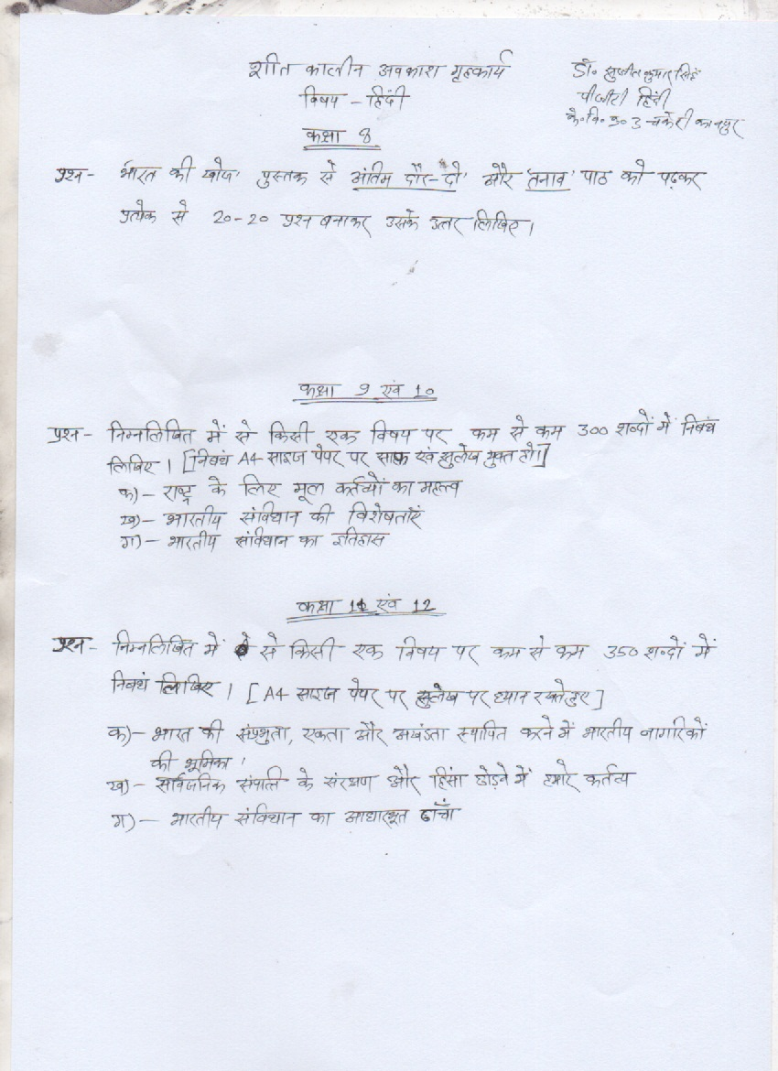

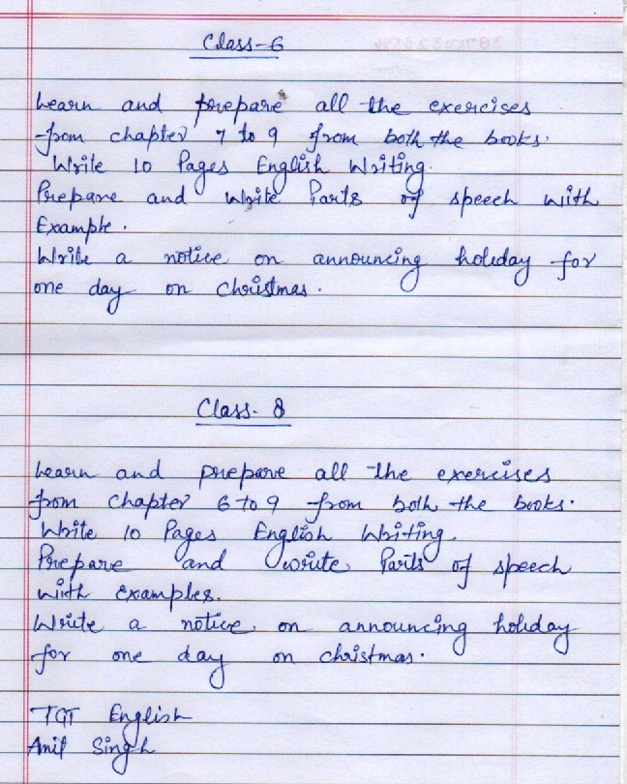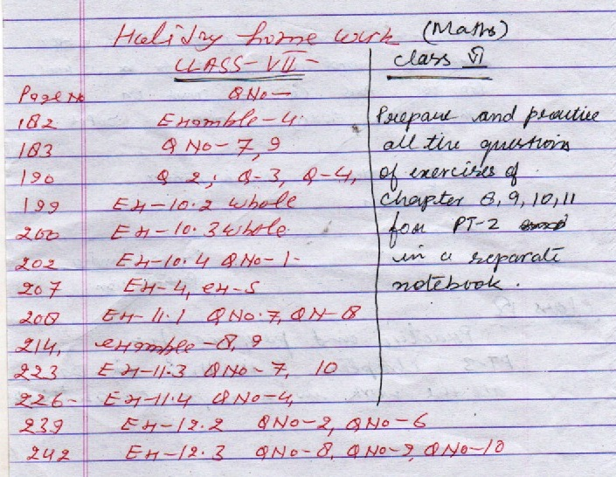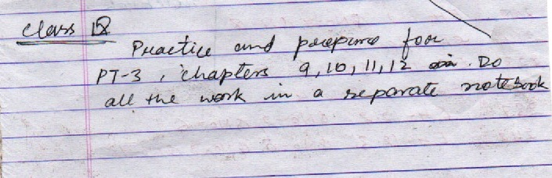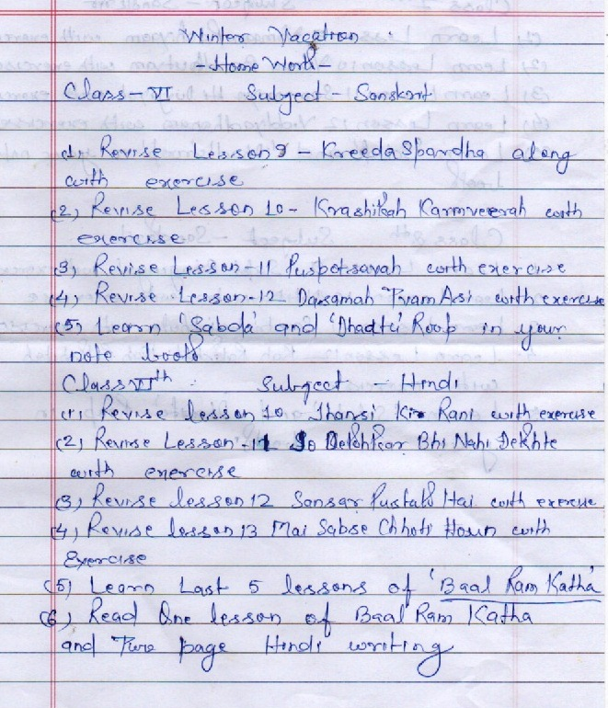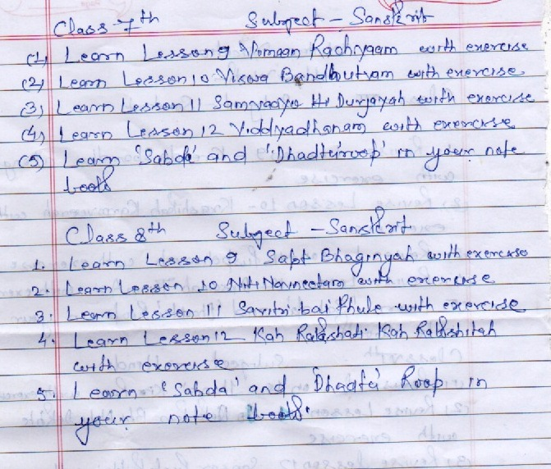
HOLIDAYS HOMEWORK FOR THE WINTER VACATION 2019
English

CLASS 10
- Solve any five sample papers in your classwork notebook and come with the problems to be discussed.
CLASS 12TH
- Solve any five sample papers of last year board exams with special attention to be given on the practice of the questions of writing section.
CLASS 11TH
- Prepare well for PT2 scheduled to be held in January.
- Prepare a role play in a group of 4 to 5 students depicting any story/ any social issue with its solution. This will be assessed against speaking activity for class 11th.
- Write short paragraphs in about 120 words on-
- Euthanasia- right or wrong.
- Where there is a will, there is a way.
- Excessive use of mobile phones.
- Report writing on Annual Sports Day.

Science
Class 4 & 6
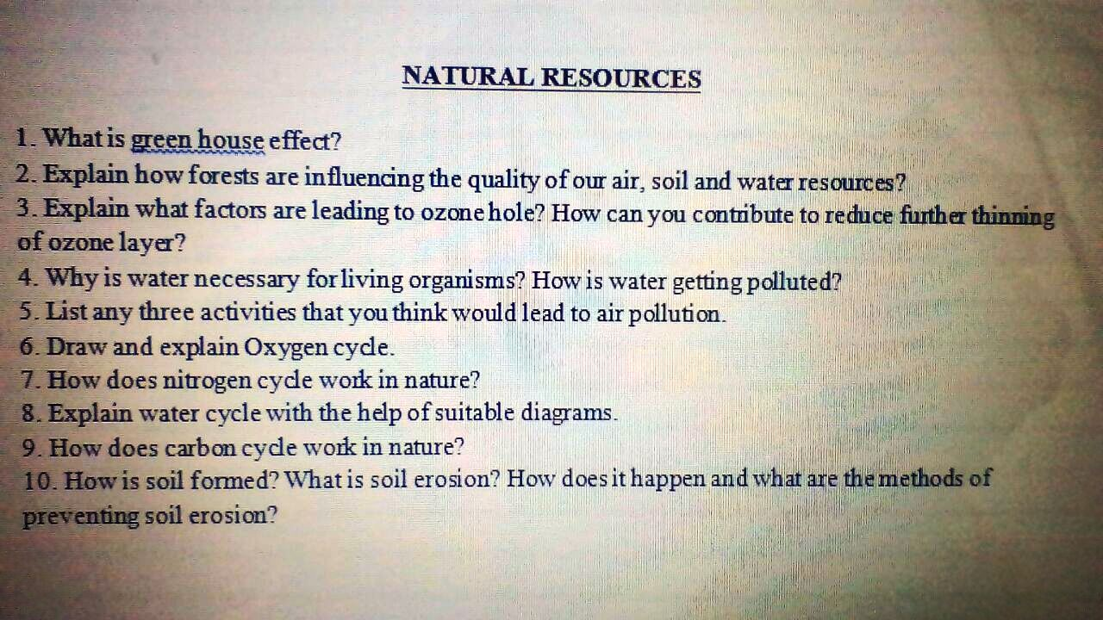
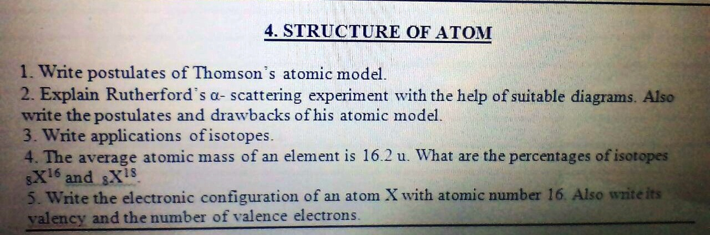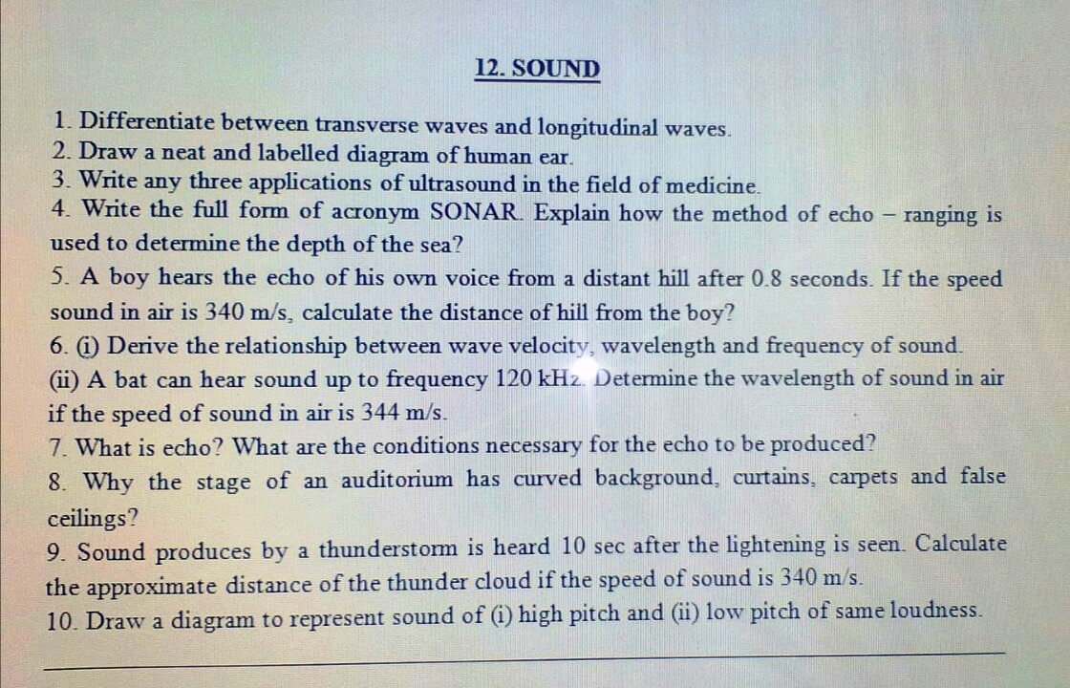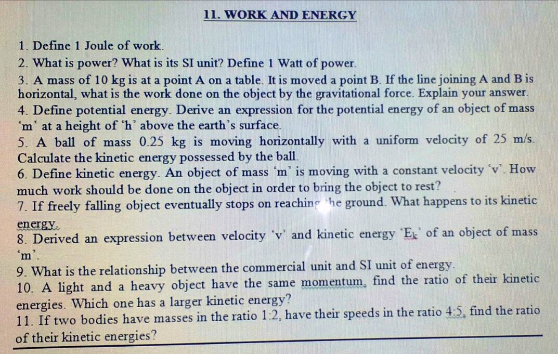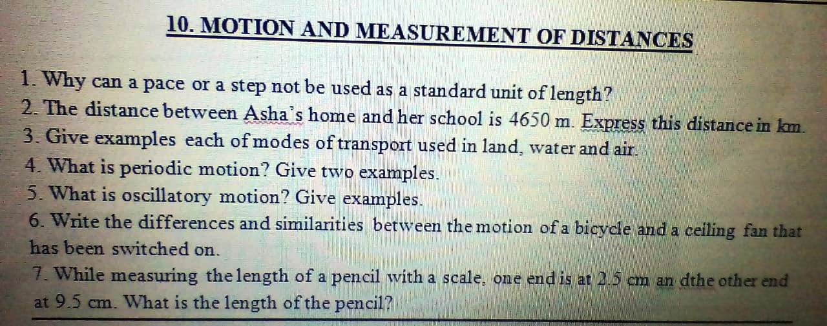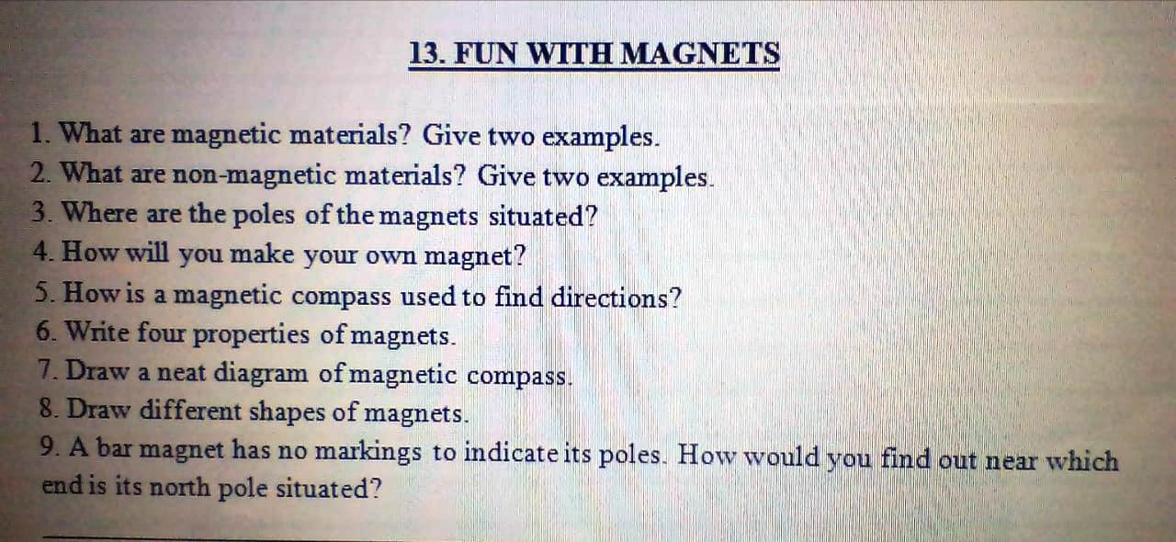
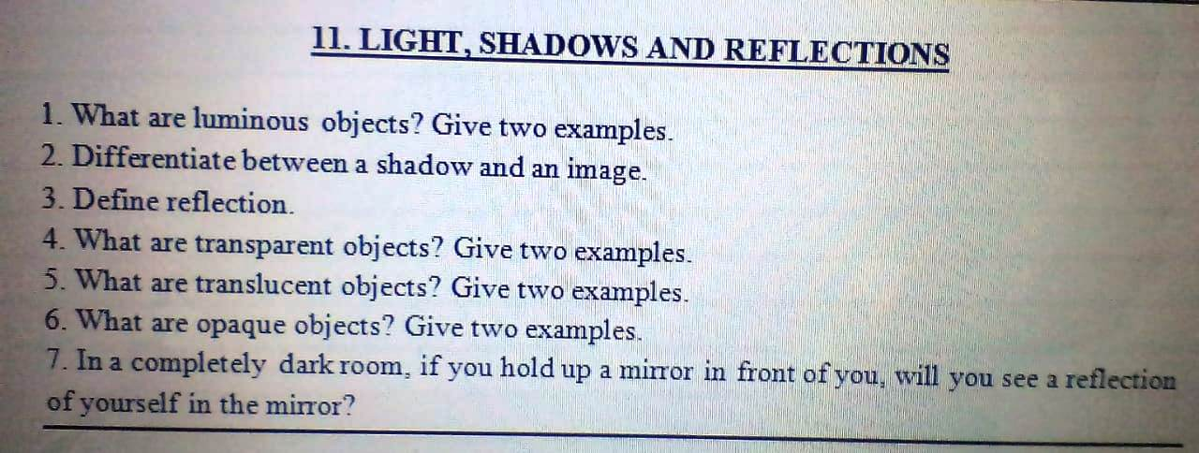
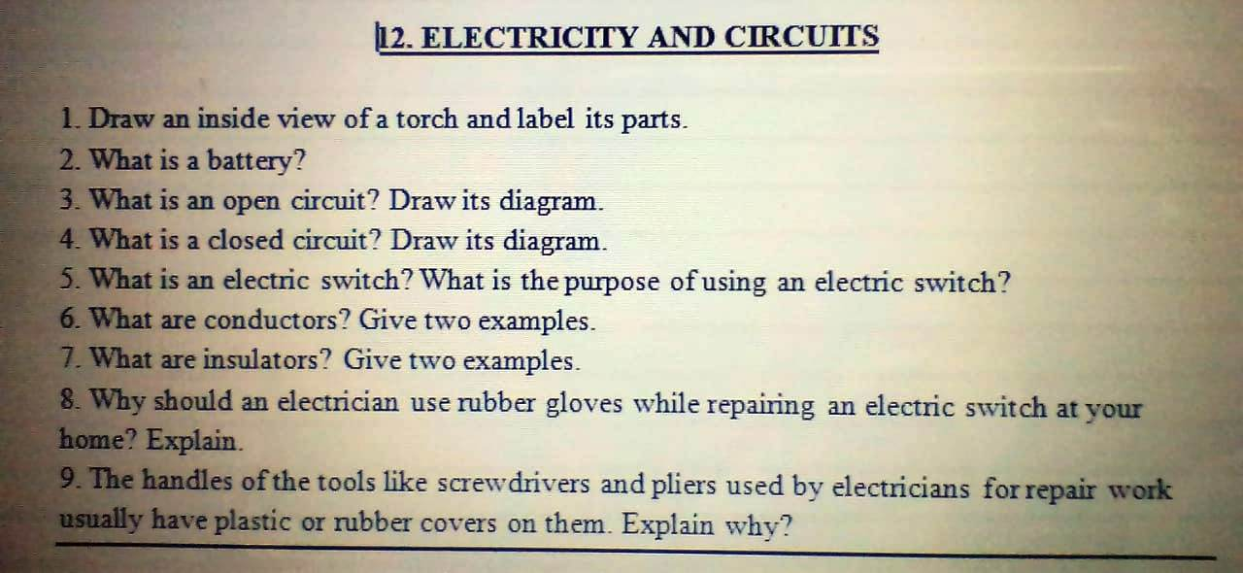
Winter break holiday homework 2019-20
Class VII
Q.1 Learn the Language based exercises given after chapter 6,7,8,9, both books.
Q.2 Learn and write the definitions of Noun, Pronoun, verb Adjective, Adverb.
Q.3 write notice, message, Informal& formal letter. (each one)
Q.4 Do any two unseen passage.
Class Ix
Q.1 Learn the Language based exercises given after chapter 6,7,8,9,(both books)
Q.2 Learn and practice the definitions of Tenses, modals, active &passive voice, direct and indirect speech.
Q.3 write notice, message, Story, diary entry, Informal& formal letter.
(each one)
Q.4 Do any three unseen passage both books.
ClassX
Q.1 Learn the Language based exercises given after all chapters,(both books)
Q.2 Learn and practice the definitions of Tenses, modals, active &passive voice, direct and indirect speech.
Q.3 write notice, message, Story, diary entry, Informal& formal letter.
(each one)
Q.4 Solve any three CBSE sample paper .
Q.1 Learn the Language based exercises given after chapter 6,7,8,9,
Q.2 Learn and practice the definitions of Tenses, modals, active &passive voice, direct and indirect speech.
Q.3 write notice, message, Story, diary entry, Informal& formal letter. (each one)
Q.4 Do any three unseen passage both books.
By A.K.BAJPAI
(TGT ENGLISH)

